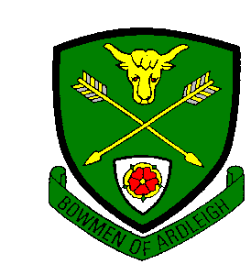
Bowmen of Ardleigh
Small Newsletter No. 99
October 2017

I'll start with the results of our last Essex Summer Albion League, in September!

Noak Hill |  | Ardleigh
G. Bridge | 809 | Sean Hunter | 768
K. Willett | 726 | Jason Horsley | 713
L. Easton | 706 | Chris Pollard | 692
A. Horne | 705 | Ken Dell | 660
I. Saunders | 697 | Chris Lowe | 645
Totals | 3643 |  | 3478
Miss R. Easton | 682 | Paul Campion | 609
B. Lock | 660 | Colin Vaughan | 603
T. Gedalovitch | 560 | Gary Prior | 560

A win for Noak Hill by 165 points! The final positions in Division 3 are

 | Shot | Bye | Didn’t shoot | Won | Lost | Draw | Points | Aggregate
Noak Hill | 4 | 1 | 0 | 4 | 0 | 0 | 8 | 14800
Mayflower | 3 | 1 | 1 | 3 | 1 | 1 | 6 | 11490
Ardleigh | 4 | 1 | 0 | 2 | 2 | 0 | 4 | 14160
Rush Green | 4 | 1 | 0 | 1 | 3 | 0 | 2 | 12977
West Essex ‘C’ | 3 | 1 | 1 | 0 | 4 | 0 | 0 | 8897

As it’s 2 up and 2 down between Division 2 and 3, Noak Hill and Mayflower go up and we stay where we are!

We’ll be meeting Malgrave and Abbey next year. Mark Turner maintains that there’s a better class of sandwich in Division 3 anyway!

Now we have pictures!
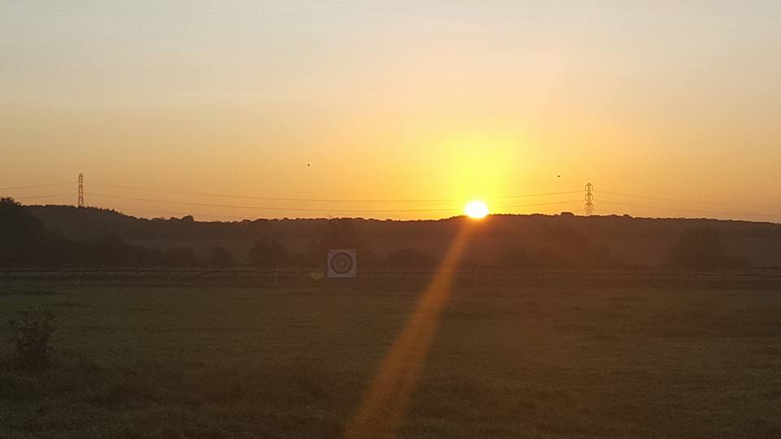
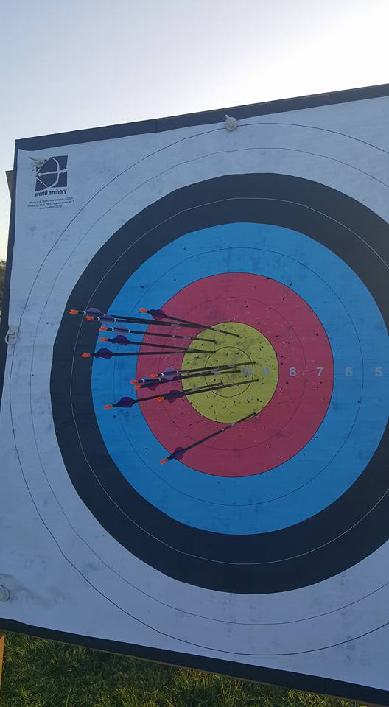
These views are from Sarah Bettle’s Facebook page. At the level Sarah is at, some sunrise and evening shooting is usually necessary and something you have to do when you work for a living, aside from all the other things people do now! Shooting once a week will get you to a reasonable standard. An extra practice day will likely see an improvement, if the practice is right. Then, if circumstances permit, perhaps practice on an extra day will help. To get to Sarah’s level, shooting every day is a necessity. When I was” on the circuit” (happy days!) I was shooting four times a week at Club or competition and three times a week shooting at home in our garage. (An understanding family is an asset!). The top British archers shoot a minimum of 400 arrows a day (I understand the Koreans shoot a minimum 1000 but I doubt they have to work for a living as well!). Few archers aspire to shoot to this level but if the opportunity comes and you can take advantage of it please do. Sarah is an example of what is possible when people put the work in. If you are happy just to enjoy shooting arrows at the Club that’s equally good.

Sarah won the UK Masters’ Competition for 2017 and had great results in the National series run during the year, finishing 3rd at the last one in September with firsts in two of the previous 4. Sarah was selected to shoot for England in the Home Nations Championship (Team Bronze), and for Great Britain in Berlin in August) and is, as this is written, in the GB Team for the World Championships in Mexico City. At the moment, Sarah is the Highest placed British Archer, in 38th place on 640 for the 70m round (1st place is a Korean lady on 688!). Naomi Folkard is 43rd on 637 and Bryony Pitman 46th on 635. All our ladies are through to the Team Competition in 13th place. For the men, Patrick Huston is 20th on 658, Tom Hall 67th on 636 and Alex Wise 87th on 626. Our men’s team are 18th and also into the finals.

As a final note, our Mixed Team of Patrick Huston and Naomi Folkard won the Bronze Medal, beating Japan. (First were Korea with Germany second. Worthy of note is that Naomi Folkard has acknowledged that without Sarah’s qualifying score Great Britain would not have been in the Bronze medal match.
This is a photo of Sarah shooting in the last National Series Competition in September. A good demonstration of keeping her bow arm pointed at the target until the sound of the arrow hitting comes back. Also bringing her drawing hand straight back along her jaw line after the loose. Some of our members may have heard me banging on about this before! Notice also that the fingers on her drawing hand are relaxed, indicating that, rather than “letting go”, Sarah just “didn’t hold the string any more”, hence no tension in the drawing hand. Good shot of the arrow on its way as well!

The other useful thing is that Sarah has total confidence in her Archery Technique. If you get the chance, have a look at the Bronze Medal Match at the Hyundai Competition in Berlin. Great Britain lost by small margins in the set matches but all the team’s shooting was top class under great pressure.
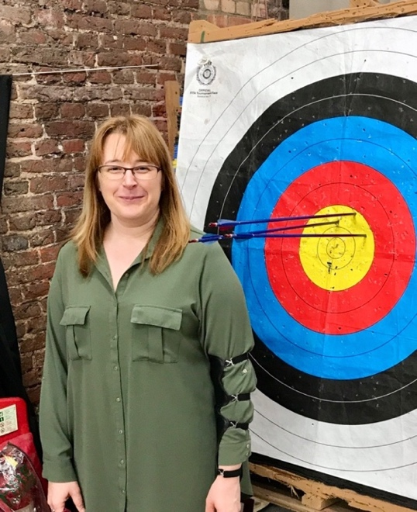
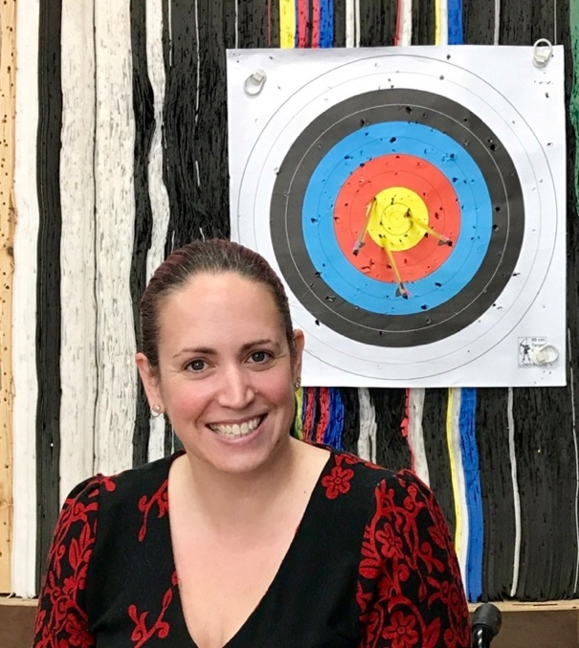

Shown above are Catherine and Emma, both looking very pleased, at the first session of our October 2017 Beginners’ Course. I think they show great promise!! All the people taking their first lesson seemed to enjoy the session and all being well this should continue in whatever direction their Archery progresses.

You will find attached at the end of this newsletter the results of our 57th Annual Field Championships held on 8th October 2017. Worthy of note is that this is the same day as Our Hon. President’s Birthday. I’m sure Tom won’t mind me iterating the information that he is now 92, and celebrated by winning the handicap competition on the day!

Another note that we need members’ help on the Beginners’ Course running presently. There is one more session, in the barn and this will be on this coming Sunday, 29th October. With, so far, two exceptions, the course is again being supported by the same people that always do it. I will ask again for more assistance from members, whether you consider yourselves not experienced enough to assist or not. The only way you’ll find out how we do it is to come along and do it, especially our more recently-joined people who can relate to those taking the same course they did only a short time before. If needs be, just come and watch as we really need people to take on some of the tasks presently done by those who’ve been involved for many years. I don’t think (hopefully!) Jann will mind if I say that if you add together the ages of our Hon. President, the Treasurer and the Secretary you get a total of 236 years! We’re fortunate in having a good number of younger Committee members, two of whom started with us as juniors but people do need to take an interest in what goes on.

Things don’t get done by magic and there’s a lot of “management” going on in the background all the time to make sure things run smoothly (most of the time anyway!). Paul Campion does a lot of work with our website and is also running a trial run on a new Handicapping and Members’ Records system and he’s not on the Committee so if people just take on one task (perhaps help in keeping the container tidy, for example) it’s a great help to our Club. As the electrician’s saying goes, “many hands make light work” (The old ones are the best!)

I can feel a touch of “how things once were” coming on. Having written to Tom Hall in the May, my first proper lesson in Archery was early in June (1970!) and there were 6 weekly sessions so I joined around the middle of July. Members then were expected to have their own equipment within 6 weeks of joining so towards the end of August I trundled along to The Archery Shop in Forest Hill. This was an outlet for Sherwood Archery who had a factory nearby and I bought a “Raven” one piece bow with an arrow rest and string, a “Rawlings” leather belt and quiver (£5.25p in new money and I still have it, somewhere), a set of “Practistreak” aluminium arrows (£5.25p for 8. “Silverstreak” arrows were the top of the range and cost £6.30p and came polished), a tab and bracer, a leather score pad (still using it now!) and a case with an arrow rack to put it all in. Altogether it cost me £40, sounds reasonable until you factor in that that was about two weeks’ wages for me at the time, after tax. Anyway, I digress.

When I started in Archery, one of the first things I did was get a handicap rating. I needed one to shoot in the Western Round in the Club Championships on 27th September. All the intake with me at the time wanted to shoot in the Annual Championships (Bob Leeming, Tony Henley, et al) so, by early September we had our equipment and handicap tables and shot three rounds, the last one of the three required on Saturday 26th September so we all had handicaps by the 27th. So, we knew our handicaps and gave the final American round score to Cliff Jolly, the Records Officer then. How the handicapping system worked was something all the members then understood. It wasn’t that we didn’t trust the Records Officer but it was good to know your allowances were correct and the sort of standards you needed to achieve with the rounds shot. Some (but not many) of our current members know how the system works, and it’s a lot more straightforward now than it used to be. It’s also the only way you can compare how you’ve progressed when you shoot different rounds.

Target fees then were 6d (2.5p). I shall continue in this vein in the next issue, all being well!

These are the results of our October Spoon Shoot.

 | Archer | H/C | Allowance | Score | Total
1 | Ken Dell | 65 | 1070 | 381 | 1451
2 | Mark Turner | 40 | 910 | 523 | 1433
3 | Dave Clegg | 43 | 922 | 506 | 1428
4 | Jason Horsley | 31 | 881 | 500 | 1381
5 | Brian Harris | 54 | 980 | 380 | 1360
Congratulations, (once again!) to Ken. Presently, Ken is the only member to have shot the 6 Spoon Shoot rounds minimum required this year to qualify for our Annual Spoon Shoot Trophy for 2017. With 2 shoots remaining, the following members are in with a chance of joining him in that competition; Dave Clegg, Mark Turner and Gary Prior on 5 shoots, and Chris Pollard and Chris Lowe on 4.
THE BOWMEN OF ARDLEIGH
57th FIELD CHAMPIONSHIPS
8TH OCTOBER 2017
COMPETITIONS ON STRAIGHT SCORE.
Gentlemen’s Recurve Championship
 | Archer | Rnd.1 | Rnd. 2 | Total
1 | Mark Turner | 80 | 81 | 161 | Baldwin Trophy and Gold Medal
2 | Ken Dell | 89 | 68 | 157 | Silver Medal
3 | Paul Campion | 72 | 70 | 142 | Bronze Medal
4 | Chris Pollard | 63 | 72 | 135
5 | Brian Harris | 53 | 47 | 100
6 | Dennis Kenny | 43 | 50 | 93
7 | Gary Prior | 35 | 26 | 61

Ladies’ Recurve Championship
 | Archer | Rnd.1 | Rnd. 2 | Total
1 | Jo Rose | 68 | 62 | 130 | Monk Shield and Gold Medal
2 | Sheron Easter | 52 | 56 | 108 | Silver Medal
3 | Claire Jones | 31 | 46 | 77 | Bronze Medal

Junior Ladies’ Recurve Championship
 | Archer | Rnd.1 | Rnd. 2 | Total
1 | Jessie Horsley | 13 | 15 | 28 | Trophy and Gold Medal
2 | Lucie Horsley | 3 | 0 | 3 | Silver Medal

Junior Gentlemen’s Recurve Championship
 | Archer | Rnd.1 | Rnd. 2 | Total
1 | Ryan Hall | 41 | 51 | 92 | Trophy and Gold Medal

Gentlemen’s Longbow Championship
 | Archer | Rnd.1 | Rnd. 2 | Total
1 | Jason Horsley | 52 | 57 | 109 | George Weaver Silver Bracer and Gold Medal
2 | Tom Hall | 21 | 53 | 74 | Silver Medal

COMPETITION ON HANDICAP
The Handicap Allowance is the difference between the highest score for the first round and the scores for those below. This is added to the score for the second round.
 | Archer | Rnd. 2 | All.
1 | Tom Hall | 53 | 68 | 121 | Wright Shield and Gold Medal
2 | Claire Jones | 46 | 58 | 104 | (24 hits) Callard Trophy and Silver Medal
3 | Jessie Horsley | 28 | 76 | 104 | (9 hits)
4 | Ryan Hall | 51 | 48 | 99
5 | Dennis Kenny | 50 | 46 | 96
6 | Chris Pollard | 72 | 23 | 95
7 | Jason Horsley | 57 | 37 | 94
8 | Sheron Easter | 56 | 37 | 93
9 | Mark Turner | 81 | 9 | 90
10 | Paul Campion | 70 | 17 | 87
11 | Lucie Horsley | 0 | 86 | 86
12 | Jo Rose | 62 | 21 | 83 | (37 hits)
13 | Brian Harris | 47 | 36 | 83 | (31 hits)
14 | Gary Prior | 26 | 54 | 80
15 | Ken Dell | 68 | 0 | 68

The day had some sunshine but became slightly overcast towards the end on the competition. The day was dry with an occasional light breeze. Congratulations go to the award winners. (This was the first time Ryan had shot a Barebow Field Round!)
Thanks go to Tom Hall, our President, for presenting the prizes and Jann for organising the entries, trophies and medals. (The day was also Tom’s 92nd birthday!)

