Bowmen of Ardleigh
Small Newsletter No. 119

February 2021

Hopefully, we might be getting back to actually shooting in the near future but with nothing much of that going on in our Archery at the moment there are still some other notes below.

Firstly, though, a brief note to those who have attended our LADS and GADS events to thank them for their endeavours over the years. For those newer members and those who may become members in the future, the “LADS” are the Lady Archers Dining Society and the “GADS” are the Gentlemen Archers Dining Society. The LADS tend to have things like Quiz nights and other activities to tax the brain, as well as meals out. The GADS tend to be much more centralised on the question of drinking and eating and really nothing at all to tax their brains! Generally, their evenings begin with erudite and educated discussion about worldly problems in general and what can be done to remedy them but these do tend to descend into chaos after about 45 minutes. The last one was at the Passage to India at Upminster Bridge and it is my intention to arrange that the next one will also be there, to maintain continuity. The one at the Railway Hotel in Hornchurch at Christmas 2017 will remain in the annals of our Club and, hopefully, stay there! The LADS and GADS have also been known to meet on occasion.

I’ve heard from former member Nicky that she’ll be moving (with Kenny and Hinami!) to Turnbridge Wells, possibly at the end of this month and I’m sure they’ll take our good wishes with them.

Another member, Masud, is moving “oop North” in a little while and will also be much missed. Good news, though, is that he (and his wife!) are expecting a happy event of an addition to their family and their daughter, all being well, will shortly have a little brother or sister. This event is expected to just coincide with when they were going to move but I believe mum’s remaining down here while Masud has all the aggravation (hopefully little) involved in their move. Again, all our good wishes go with them for the future and providing their email address doesn’t change we’ll keep them in touch with our doings.

It’s just been announced that outdoor sports can commence again at the end of March and indoor sports from the middle of April. We’ll need to await Archery GB producing their guidelines before doing anything, but I’m assuming we’ll still be carrying on with Booking sessions, masks, social distancing, sanitizing, etc. for a while yet, until we’re told we needn’t worry. This may be by the middle of June but we’ll need to wait and see because much depends on the rates of infection of Coronavirus fitting in with the Government’s predictions. If all goes according to plan, and the Rule of 6 is relaxed, we may even have the Community Association’s facilities available by then as well!

Perhaps this year, when the dust has settled and with a bit of adjustment according to circumstance, we’ll be able to run all our Club Competitions during the coming season.

We also still have over 60 enquiries from people wishing to join our club, or at least have a taster session with us. There are some still awaiting the series of sessions that were never completed. We gained 3 members from the first session in March and 3 more, potentially, from the one we managed to run within the Tier 3 rules in October, before the last lockdowns. There are also a quite considerable number since then too and I’ll be getting in touch with all of them when we do have some guidelines to work with.

I think it’s safe, though, to assume we’ll be back in Tier 3 before anything else and we’re running out of time in the Indoor Season to run things in the barn. The beginners’ sessions may well need then to be outdoors when we re-start. This is still subject, though, to discussion between members, and their availability and what we can sort out with the barn, as it may well be some little while before the Manor House facilities are available to us.

For those who like pictures, shown below are our members at our Club Field Championships in September 2019! Also pictured, below left, is Sheron, shooting, I think, at the Braintree Open later in the month.
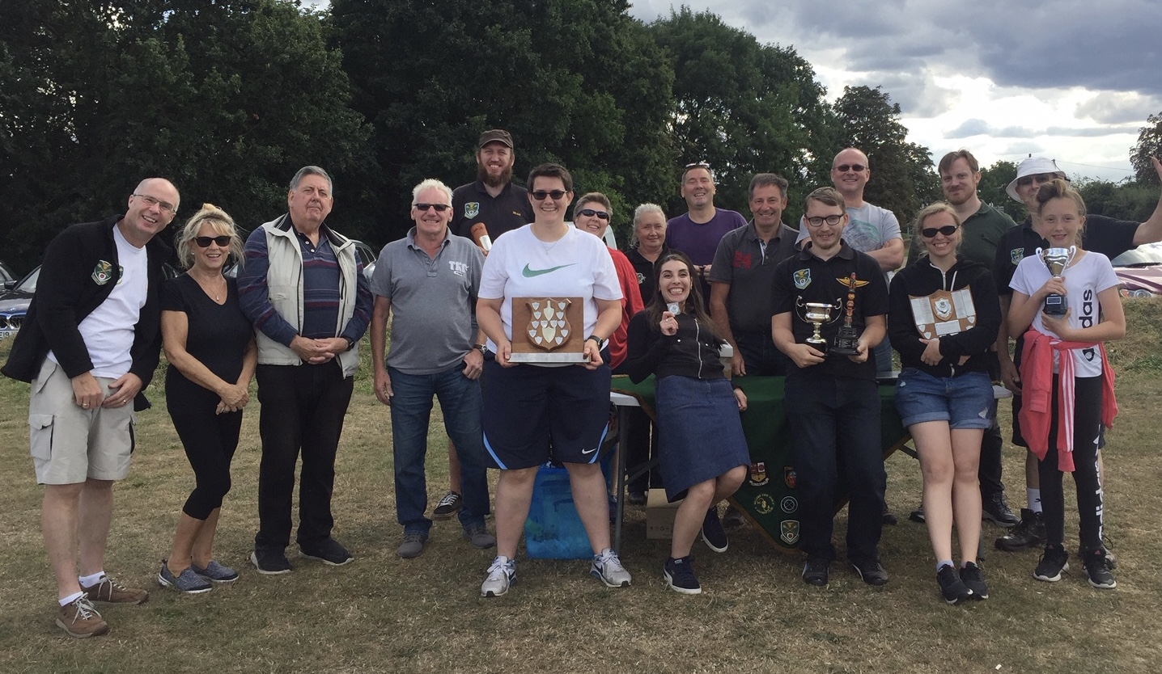
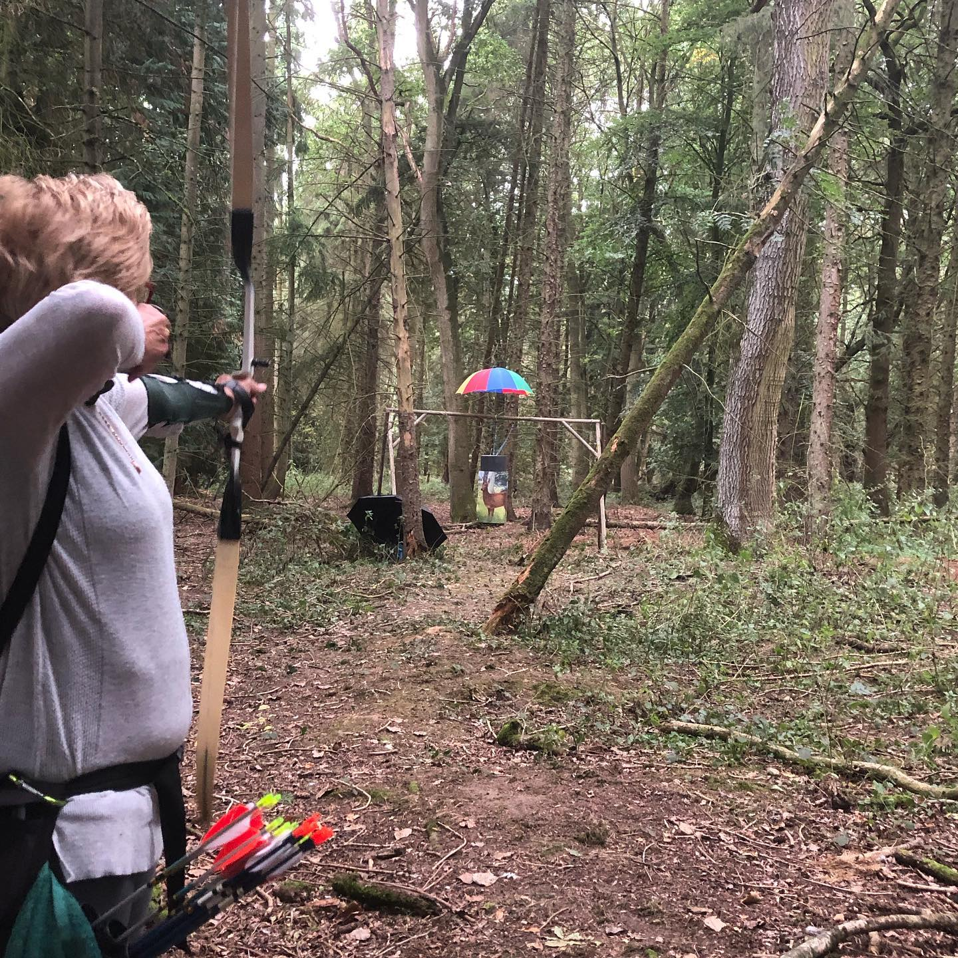
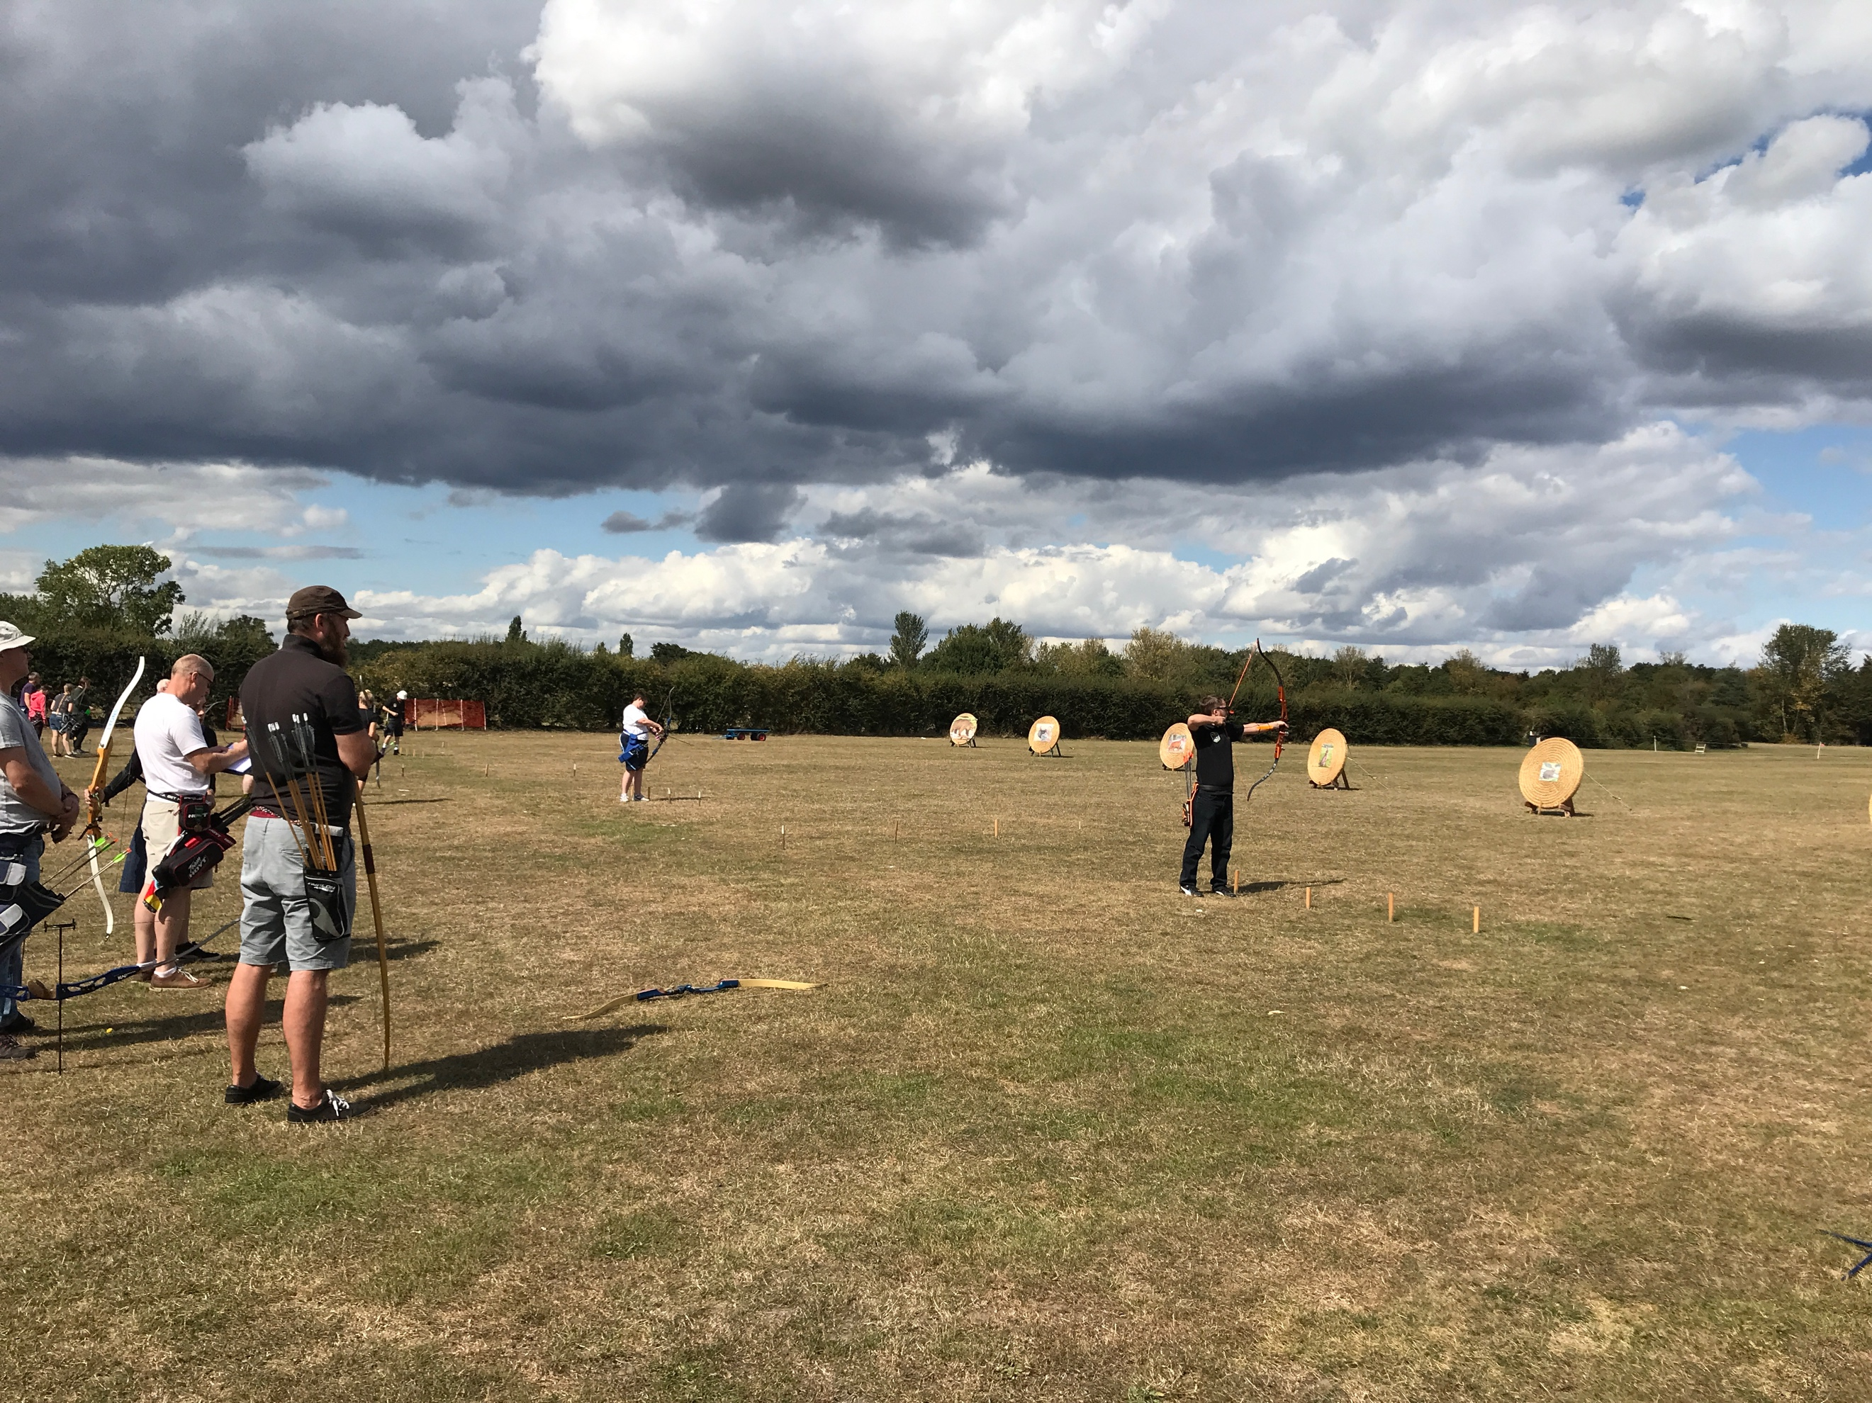

We shoot our Field Archery competitions on a flat ground but this last does give an idea of the sort of shot you get in somewhere with lots of trees. This one, though, as you can probably tell from the umbrella, is something of a novelty!

